**TRIBHUVAN UNIVERSITY**

**FACULTY OF HUMANITIES AND SOCIAL**

**SCIENCES**



Nagarjuna College of Information Technology

Sankhamul, Lalitpur

**Project Work of Python on Quiz App**

**Submitted by: Submitted to:**

Miken Maharjan Rajad Shakya

Sujal Maharjan

Bishesh Rajkarnikar

Alex Maharjan

**Acknowledgments**

We would like to express our sincere gratitude to Rajad Shakya sir for his invaluable guidance, support, and mentorship throughout the development of python course. His expertise in web development, insightful feedback, and dedication to helping me overcome challenges have been instrumental in bringing this project to fruition.

Rajad Shakya sir’s deep understanding of Django, Bootstrap, and modern web development practices has enriched our learning experience and empowered use to create a user-friendly and aesthetically pleasing application. His patient and comprehensive explanations have provided clarity in complex concepts and inspired us to strive for excellence in every aspect of the project.

We extend our heartfelt thanks to Rajad Shakya Sir for sharing his knowledge generously and encouraging us to explore innovative solutions. His mentorship has not only contributed to the success of the Restaurant Menu App but has also enriched our journey as a developer.

Once again, thank you, Rajad Shakya, for your unwavering support and commitment to nurturing the next generation of developers.

Sincerely,

Miken Maharjan

Sujal Maharjan

Bishesh Rajkarnikar

Alex Maharjan

**Top of Form**

**Project Title:** Restaurant Menu App

**Description:**

The Restaurant Menu App is a user-friendly web application designed to manage and display the menu items of a restaurant in an organized and visually appealing way. This app provides restaurant owners and administrators with a platform to easily add, update, and delete menu items, allowing them to showcase their offerings to customers in an engaging manner.

**Features:**

1. **Menu Display:** The app offers a beautifully designed main page that presents the restaurant's menu items in an eye-catching grid format. Each menu item is displayed with its name, price, and an accompanying image that highlights the item's visual appeal.
2. **Responsive Design:** The app is built with responsiveness in mind, ensuring that the menu items are displayed appropriately on various devices, including desktops, tablets, and smartphones.
3. **Easy Item Management:** The app includes an intuitive user interface for restaurant owners and administrators to manage their menu items. They can easily add new items, update existing ones, or remove items that are no longer available.
4. **Detailed Descriptions:** Users can click on a menu item to view its detailed description, including the name, price, and a high-quality image. This feature enables customers to make informed choices based on their preferences.
5. **Stylish Styling:** The app utilizes modern and clean styling, with a consistent color palette and typography that enhances the overall user experience. Styling is applied to both the main menu page and the individual menu item details page.
6. **Background Customization:** The app allows administrators to customize the background color and add a background image to enhance the visual appeal of the app and align it with the restaurant's branding.
7. **Sticky Navigation:** The navigation bar remains at the top of the screen as users scroll down the page, ensuring easy access to menu categories and the "Add Item" option.
8. **Interactive Buttons:** The app features interactive buttons for actions such as viewing item details, editing items, and deleting items. These buttons provide a seamless user experience.

**Purpose:**

The Restaurant Menu App aims to provide an elegant solution for restaurants to effectively showcase their menu offerings and manage their menu items. By offering a user-friendly interface and aesthetically pleasing design, the app enhances the restaurant's online presence and provides a positive user experience for customers exploring the menu.

Whether it's a fine-dining establishment, a casual eatery, or a café, the Restaurant Menu App offers a versatile and adaptable platform for restaurant owners to present their culinary creations to their patrons.

**Technologies Used:**

* Django: A powerful web framework for building dynamic web applications.
* Bootstrap: A popular front-end framework for creating responsive and stylish user interfaces.
* HTML and CSS: Used to structure and style the web pages.
* PostgreSQL (Optional): A robust relational database system for data storage.

**Program flow chart**

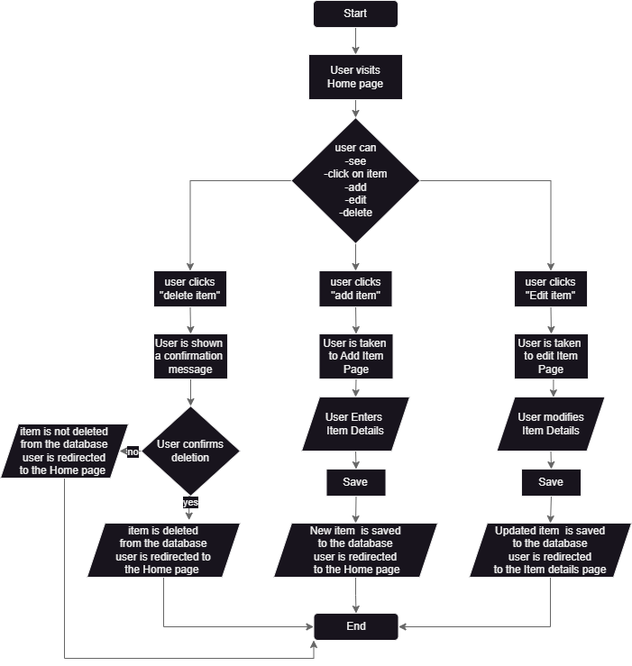

**Wireframes and UI screenshots**

**1. Main page**

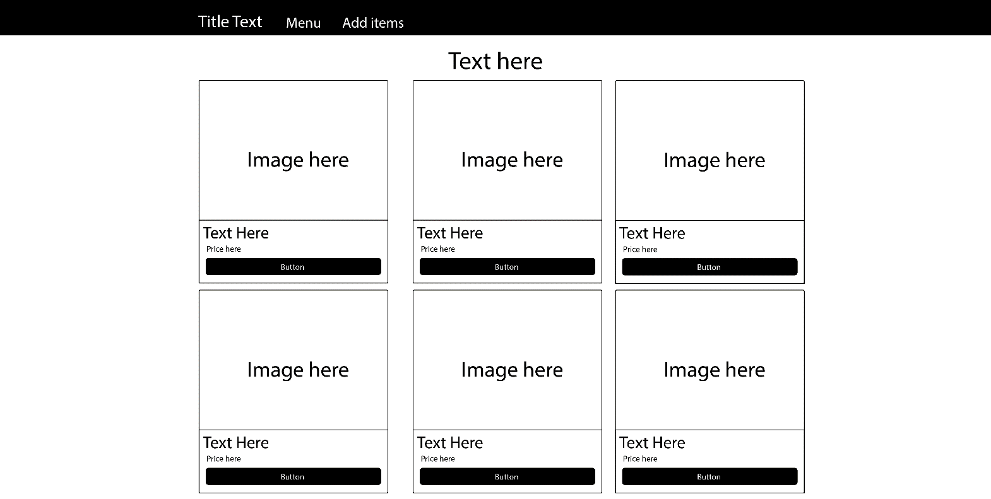

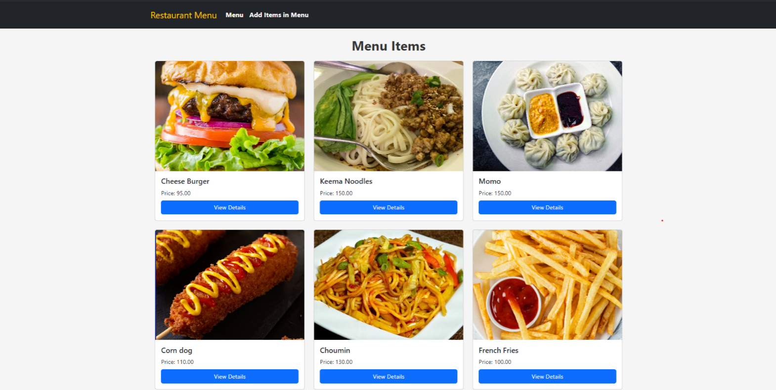

**2. Detail page**

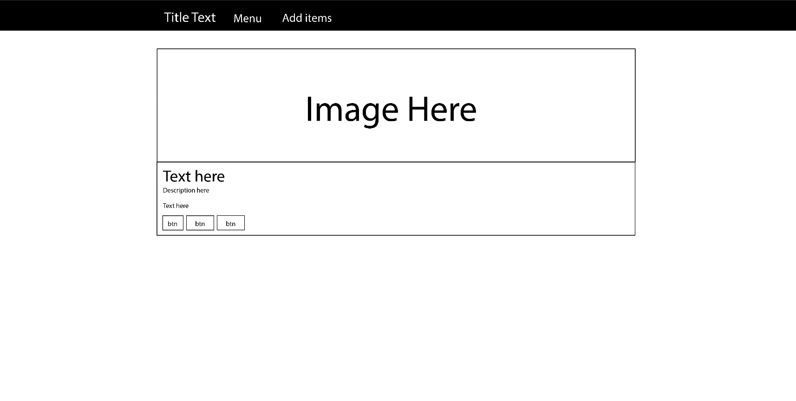

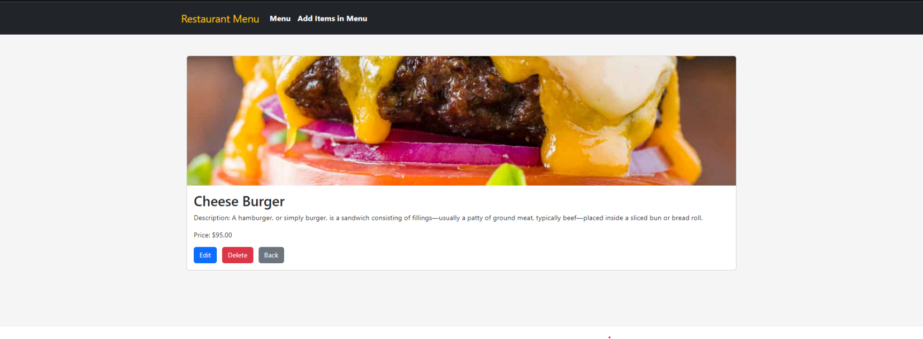

**3. Add item page**

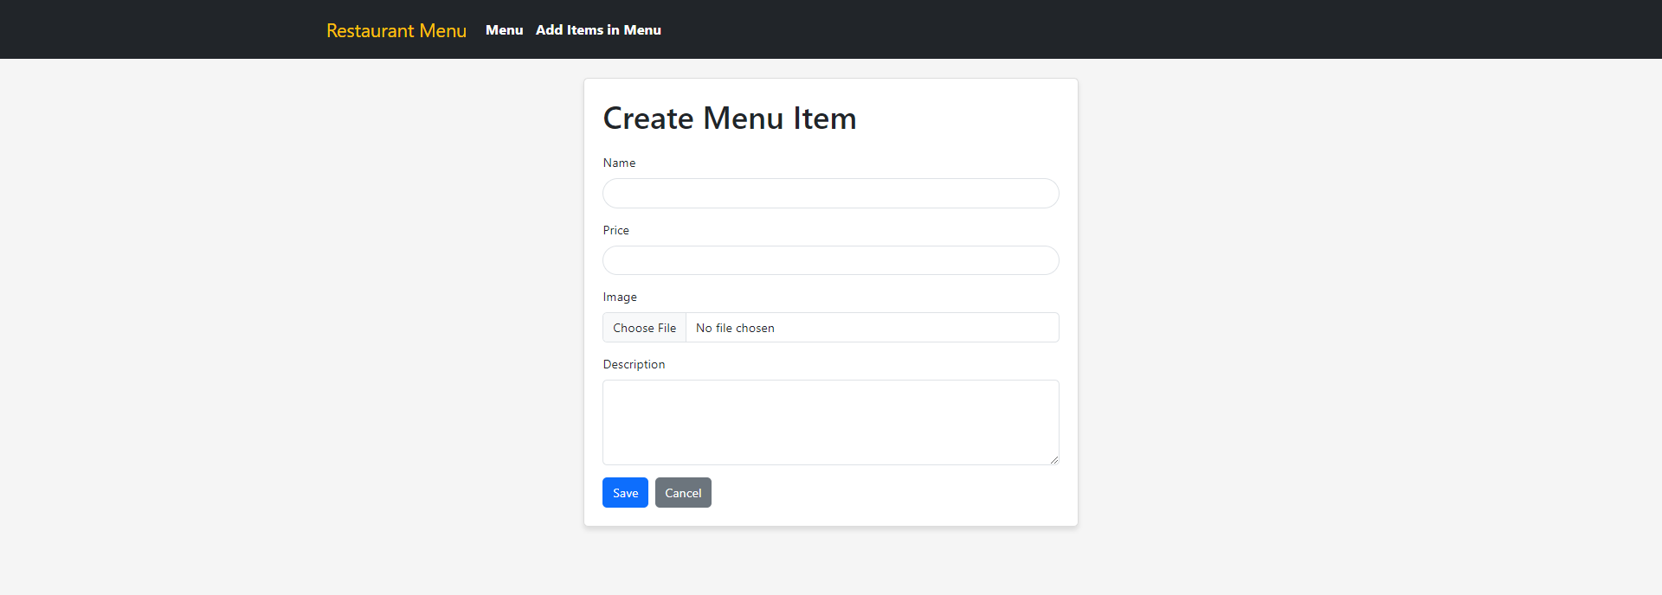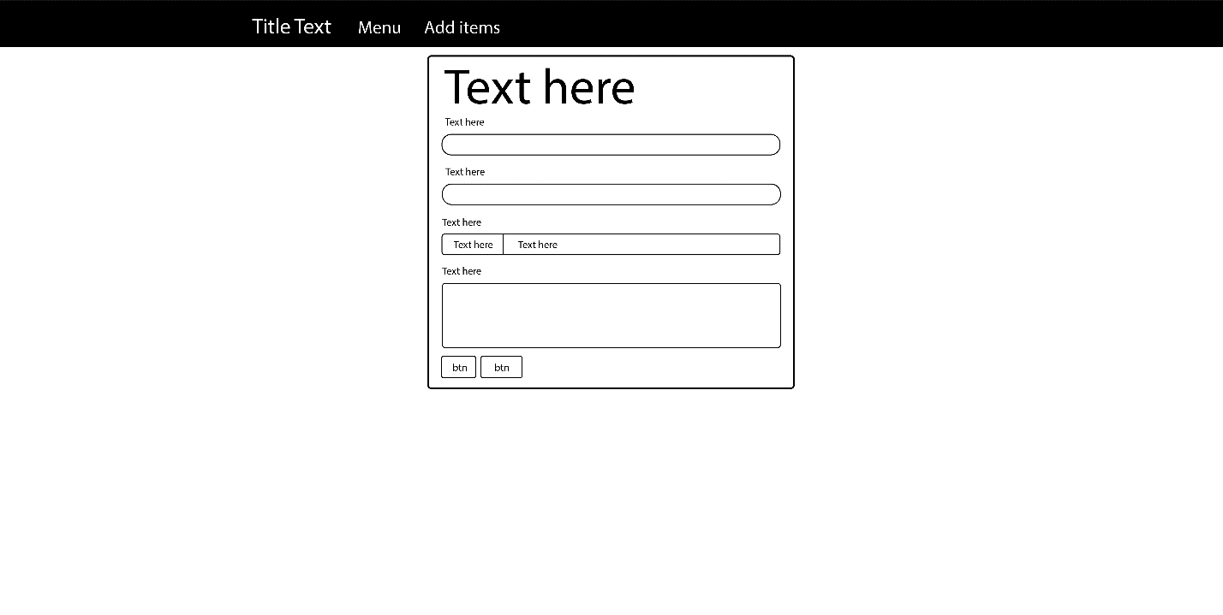

**4.Edit/Update Page**

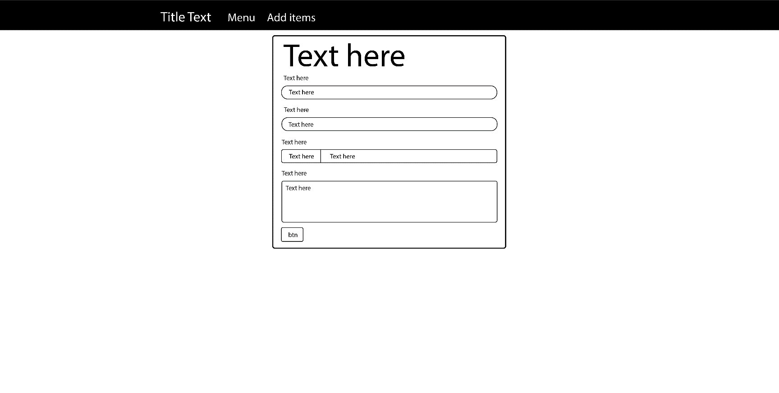

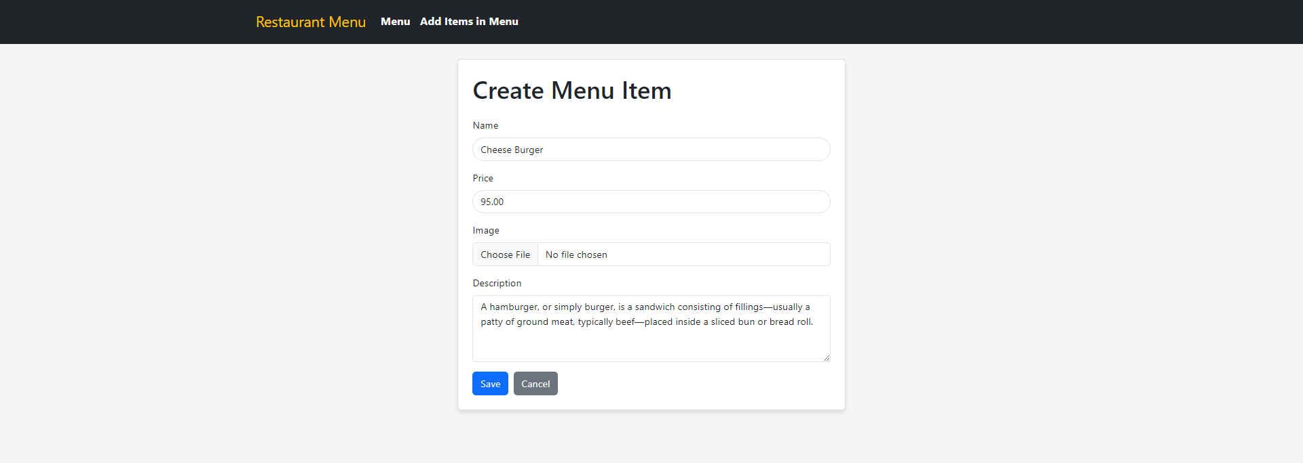

**5. Delete confirmation page**

